Implemented autoscaling on Amazon EKS using:
• Horizontal Pod Autoscaler (HPA)
• Karpenter NodePools
• EC2NodeClasses
• On-Demand Capacity
• Spot Capacity
• Spot Interruption Handling
Validated dynamic pod scaling, node provisioning,
node consolidation, and workload scheduling.
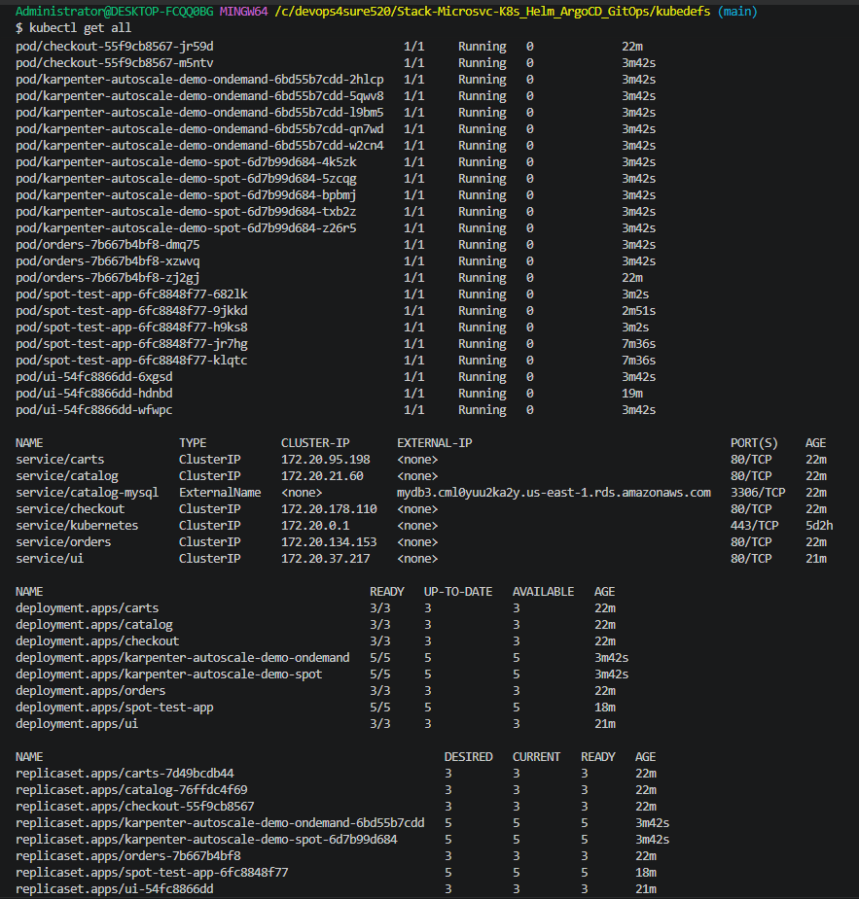
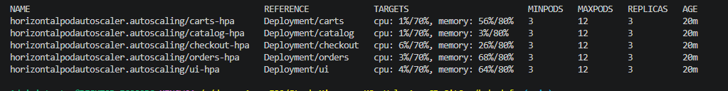
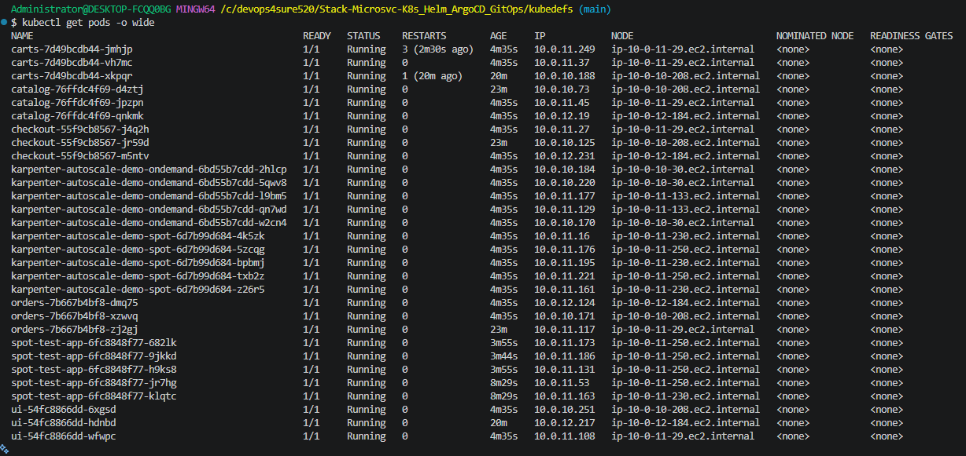
Architecture:
User Traffic
↓
Ingress / ALB
↓
Retail Store Services
↓
HPA
↓
More Pods
↓
Karpenter
↓
More Nodes
↓
AWS EC2
↓
On-Demand + Spot Capacity

